Patrick Capps

CSE 5544

Assignment 1: Tool Reviews

D3:

D3 or Data Driven Documents is a JavaScript library that allows for manipulation of Document Object Models using data. Since it is JavaScript it is usable on web pages and uses HTML, CSS, and SVG. JavaScript supports expected types such as integers, float values, and strings, and D3 offers methods to manipulate objects such as arrays, geographic projects, and time formats.

Based on the examples, D3 is capable of producing a wide variety of visualizations. Simple bar and other types of charts are doable, but people have also produced an animation of tadpoles and a map based on GDP. The API available on GitHub is extensive and offers methods for many different types of data. Since D3 is a library, its capability ultimately depends on what the developer creates with it, so it is highly customizable. This seems to be a flexible tool for data visualization which is also easy to test and runs quickly since it can be run in most browsers.

Paraview:

Paraview, unlike D3, is a complete application for data analysis and visualization, so it does not require coding and the data can be interacted with in a 3D interface. The interface provides many options to manipulate visualizations such as a color palette, scaling, and animation control. Paraview can also take advantage of Python scripting to automate certain user tasks, and a small API exists for this.

According to the tutorial, Paraview was mainly developed for spatial data so primary data types are meshes. These include rectilinear, curvilinear, polygonal, and unstructured representations, so most types of 3D visualizations can be created. There are also special data types for data types such as tabular or graph data, so users should also be able to make ordinary charts. Without direct control over all of the code Paraview may not be as customizable as a D3 project but for most uses may be a more streamlined approach.

MATLAB Visualization Images and Captions

This contour map uses color to represent the value of the DTI grid data. It was created with the MATLAB contour function and a line value of 25.

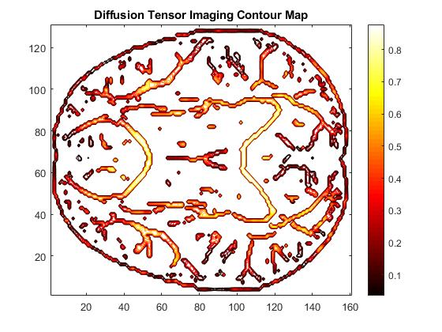

This is an attempt at a 3D visualization of the DTI values. This works best when viewed in MATLAB as a .fig file with the ability to rotate and otherwise manipulate the view.

